Alex Margaritescu, Zhe (Richard) Ren, Caroline Biel

EEB313

December 5, 2018

What’s swallowing up the birds?

Tracking swallow (Hirundinidaefamily) population declines in Ontario

**Abstract**

Aerial insectivore populations in North America are declining, but the exact causes are still unknown. The goal of our study was to quantify the population declines of six different swallow species in Ontario and to identify probable causes of these declines. We obtained 5 datasets from the North American Breeding Bird Survey that we merged in R (version 3.4.4). Our data ranged from 1967 to 2017 and contained information on the number of birds surveyed, the number of vehicles along the surveyed routes, the amount of sound pollution, map coordinates, weather conditions. To visualize swallow distribution over the years we made heatmaps and plotted swallow populations across years. We also plotted normal distributions of all swallows in relation to average weather conditions. For statistical tests we performed linear regressions to view the swallow data through the years, we made linear models to analyze the swallow abundance versus average weather conditions and ran ANOVAs to further support the data of the linear models. We found that swallows were indeed declining in Ontario. Significant influencers of swallow abundance were all three weather conditions: temperature, wind, and cloud cover. Traffic (a proxy for human disturbance) was not a significant predictor of swallow abundance. Although there were some limitations to our study due to variation in observer ability and gaps in habitat and weather data, our findings confirm that swallows are declining in Ontario.

**Introduction**

Swallow populations have been steeply declining for several decades, to the great alarm of conservationists (Smith et al. 2015). Swallows (family *Hirundinidae*) belong to a group of birds called aerial insectivores - birds that feed primarily by capturing insect prey in flight - and have been experiencing sharp population declines in both the New World and the Old World. Temporal synchrony in population trends across most aerial insectivores (flycatchers, nightjars, swallows, and swifts) suggests that there is likely a common environmental factor(s) influencing the decline of this group (Smith et al. 2015). Factors such as local weather (McArthur et al. 2017; Weegman et al. 2017); parasites on the breeding grounds (Turcotte et al. 2018); decreased fledging success (Cox et al. 2018); poor habitat quality on wintering grounds (Saino et al. 2012; Sicurella et al. 2016; Cox et al. 2018); disruptions on migration stopover sites (Sicurella et al. 2016); and reductions in preferred insect prey due to intensive agriculture (Bellevance et al. 2018) have been proposed to explain the population trends of aerial insectivores. However, the exact causes of the declines remain unidentified.

The sharp declines in swallow populations have led to many population recovery and citizen science efforts, such as the installation of artificial nest boxes, nest monitoring, swallow surveys, bird banding projects, and habitat protection. In Ontario, Barn Swallows (*Riparia riparia*) and Bank Swallows (*Hirundo rustica*) are now provincially designated as Threatened and have respective recovery strategies (Ontario, 2018). However, conservation efforts would be better guided if the causes of the decline were known.

In this study, we used route survey data ranging from 1967 to 2017 from a public dataset (the North American Breeding Bird Survey; BBS 2018) to ask whether six species of swallows are exhibiting population declines in Ontario. In addition, we asked whether local weather and traffic (a proxy for the level of human disturbance) have an impact on swallow abundance.

**Hypothesis**

Our hypothesis is that swallow populations in Ontario of the six chosen species are declining between 1967 and 2007. We also want to find the reason behind the putative decline in swallow populations.

**Methods**

Data Source

Our data were obtained from the North American Breeding Bird Survey (BBS) (https://www.pwrc.usgs.gov/BBS/). BBS uses standardized roadside bird surveys conducted by volunteer birders who are skilled in bird identification. Surveys are conducted along 50-km routes throughout North America during the summer, beginning half an hour before sunrise and requiring approximately 5 hours to complete. Birders stop at every kilometer along the route (50 stops per route) and perform a 3-minute count of all birds at the stop with the help of binoculars. They also record the number of cars passing by during the bird count at each stop, as well as the weather information of the entire route during the survey. Some routes are surveyed annually, while others are surveyed less regularly. In this study, we analyzed 9702 data entries that contained at least one swallow (family *Hirundinidae*) observation, collected in Ontario between 1967 and 2017.

Dataset Generation

We generated a mega-dataset by merging 5 datasets from BBS. They were all merged into “Swallows Data Expanded.csv” by matching columns. Since not every row in Ontario.csv had a corresponding row in the other datasets, many cells contained NA’s in the mega-dataset.

1. Ontario.csv, which contained bird counts from surveys in Ontario (1967-2017).

2. Checklist.csv, which contained the family, genus, and species names corresponding to AOU (standardized 4-digit bird species code) of all birds. We then filtered the dataset to include only the six swallow species, which resulted in 9702 entries. Each entry specifies the count for each swallow species on a route. The *SpeciesTotal* column gives the number of individuals observed on the route.

3. VehicleData.csv, which contained the number of vehicles and perceived noise level at each stop along a route.

4. Routes.csv, which contained route name, longitude, and latitude, and habitat type (stratum) of each route.

5. Weather.csv, which contained temperature, wind conditions and sky conditions for each route. The temperature recordings were not measured consistently in one unit, so we standardized the data by converting all measurements to Celsius.

Distribution Plots

We used *maps* and *mapdata* packages in R to draw a map of the part of Ontario in which all our data is taken from. We overlaid cities with population > 110,000 on the map to help identify the location of different routes, then overlaid the swallow abundance of each route based on latitude and longitude of the routes. We separately mapped the swallow distribution for each species and every year between 1994 and 2015, in which there were the most numbers of surveys. Each dot represents a route where swallows were observed during the year, the size and color of each dot represent the number of swallows observed on the route. We then used Windows Movie Maker to create MP4 animations for the distribution change of each species between 1994 and 2015.

Statistical Tests

All statistical tests and plotting were performed in R (version 3.4.4). We performed multiple regression to test if swallow population declines were significant over the study period. We built a linear model that predicted the effect of year, species, and their interaction on the average number of swallows seen per route. We averaged the response variable in order to conform the data to the assumptions of linear regression; the raw data tended to be heteroskedastic and not normally distributed, even after attempting logarithmic and square-root transformations. When the data violated the assumptions of linear regression such as normality or equal variances, we log-transformed the response variable before performing ANOVAs. The significance threshold was set to 0.05.

In addition, we investigated how population trends of swallows differ between four strata (habitat types) in Ontario. We constructed linear models for each species that predicted the effect of year, stratum (habitat type), and their interaction on the average number of swallows seen per route. Since stratum classification was only recorded since 1994, we could only use stratum as a predictor for part of the study period.

Since temperature, wind level, and cloud cover were recorded at both the start and end of surveys, we used the average of start and end measurements for our analyses. Next, we ran linear models of year and average weather conditions to test if there were any significant changes in weather conditions over the years. We ran summaries of linear models and plotted the linear models of swallow abundance in relation to the average weather conditions. We also ran ANOVAs on the linear models of the swallow abundance versus the average weather conditions for further reinforcement of significance.

**Results**

Distribution Plots

We have embedded the MP4 animations for the distribution of six species of swallows. These animations only give a general idea that swallow distribution has been declining. We have performed statistical analyses to demonstrate that swallow abundance is indeed declining, presented later.



Barn and Tree Swallows are the most abundant species of the six, followed by Bank and Cliff Swallows. Our animations show a decrease among all these species in the number observed among routes in Ontario from 1994 to 2015.



Purple Martins and Northern Rough-winged Swallows are the least abundant species among the six. Our animations show a decline in the number of routes in Ontario where they were observed from 1994 to 2015, signaling a range shrinking in these species.

(These MP4s are can be opened from the word document, but unfortunately not from the PDF. They are also uploaded into the Github folder if you need to view them.)

Swallow Abundance as Affected by the Factors of Year, Strata, Weather, and Traffic

Species, year, and their interaction were significant predictors of the average number of swallows per route during the full study period from 1967 to 2017 (Figure 7; P < 0.001, R-squared = 0.7929).

When the effects of year, stratum, and their interaction on the average number of swallows per route were tested on each of the six swallow species separately through multiple regression, we found that the interaction was only significant for two swallow species: Barn Swallow and Tree Swallow. In Barn Swallows, one stratum in particular (the St. Lawrence River Plain) drove population declines, whereas abundance appeared to be stable (Closed Boreal Forest and Northern Spruce-Hardwoods) or even increasing (Great Lakes Plain) in the other strata (Figure 8A; P < 0.001, R-squared = 0.9271). Tree Swallows declined in the Great Lakes Plain and Northern Spruce Hardwoods in the log-transformed model but remained stable in the other two strata (Figure 8B; P < 0.001, R-squared = 0.7808).

There was no significant change in temperature and sky conditions throughout the study period. There was a slight but significant change in wind conditions across the years. The average temperature was the greatest predictor of the number of birds spotted, followed by average wind and average sky (Figure 12 and Figure 13). Finally, we used a linear model to examine the effect of traffic on swallow abundance and found that there was no significant impact on swallows (Figure 14 and Figure 15).

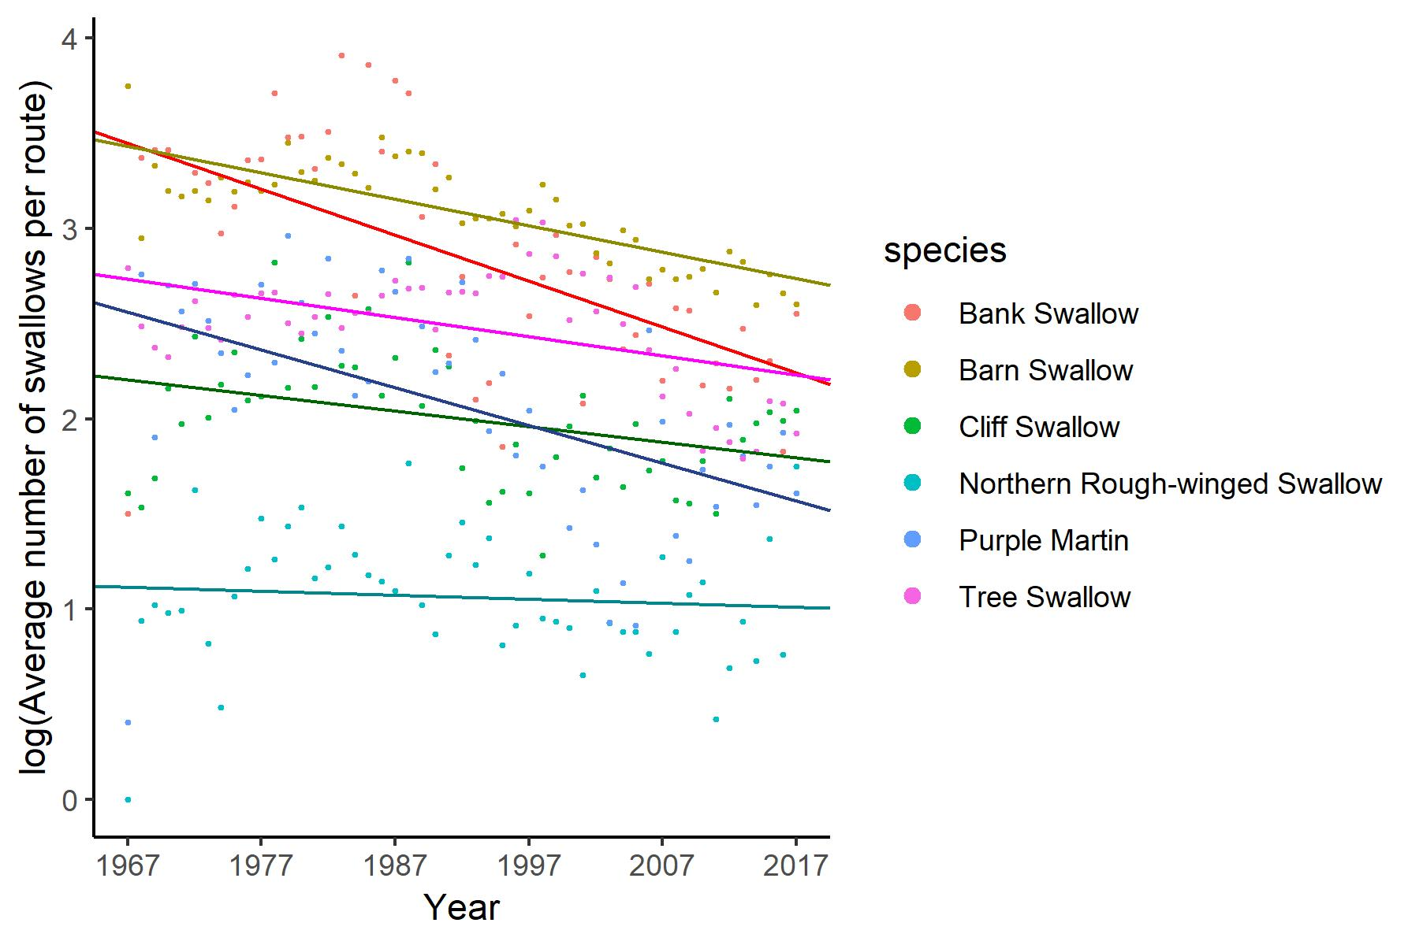

Figure 7. The interaction between year and species on the log-transformed number of swallows per route. Year, species, and their interaction were all significant predictors of swallow abundance (P < 0.001, R-squared = 0.7929, n = 306).

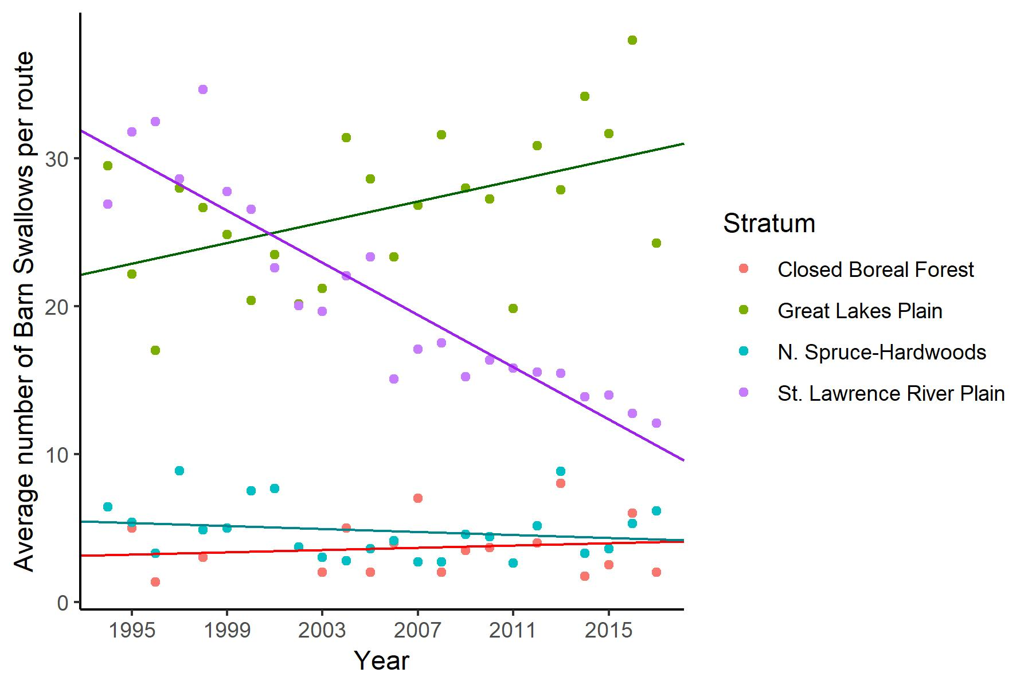

Figure 8A. Average number of Barn Swallows per route by stratum from 1994 to 2017.

Stratum, as well as the interaction between stratum:year, were significant predictors of average Barn Swallow abundance (P < 0.001, R-squared = 0.9271, n = 89). The interaction was significant for the St. Lawrence River Plain (P < 0.001) and the Great Lakes Plain (P < 0.05).

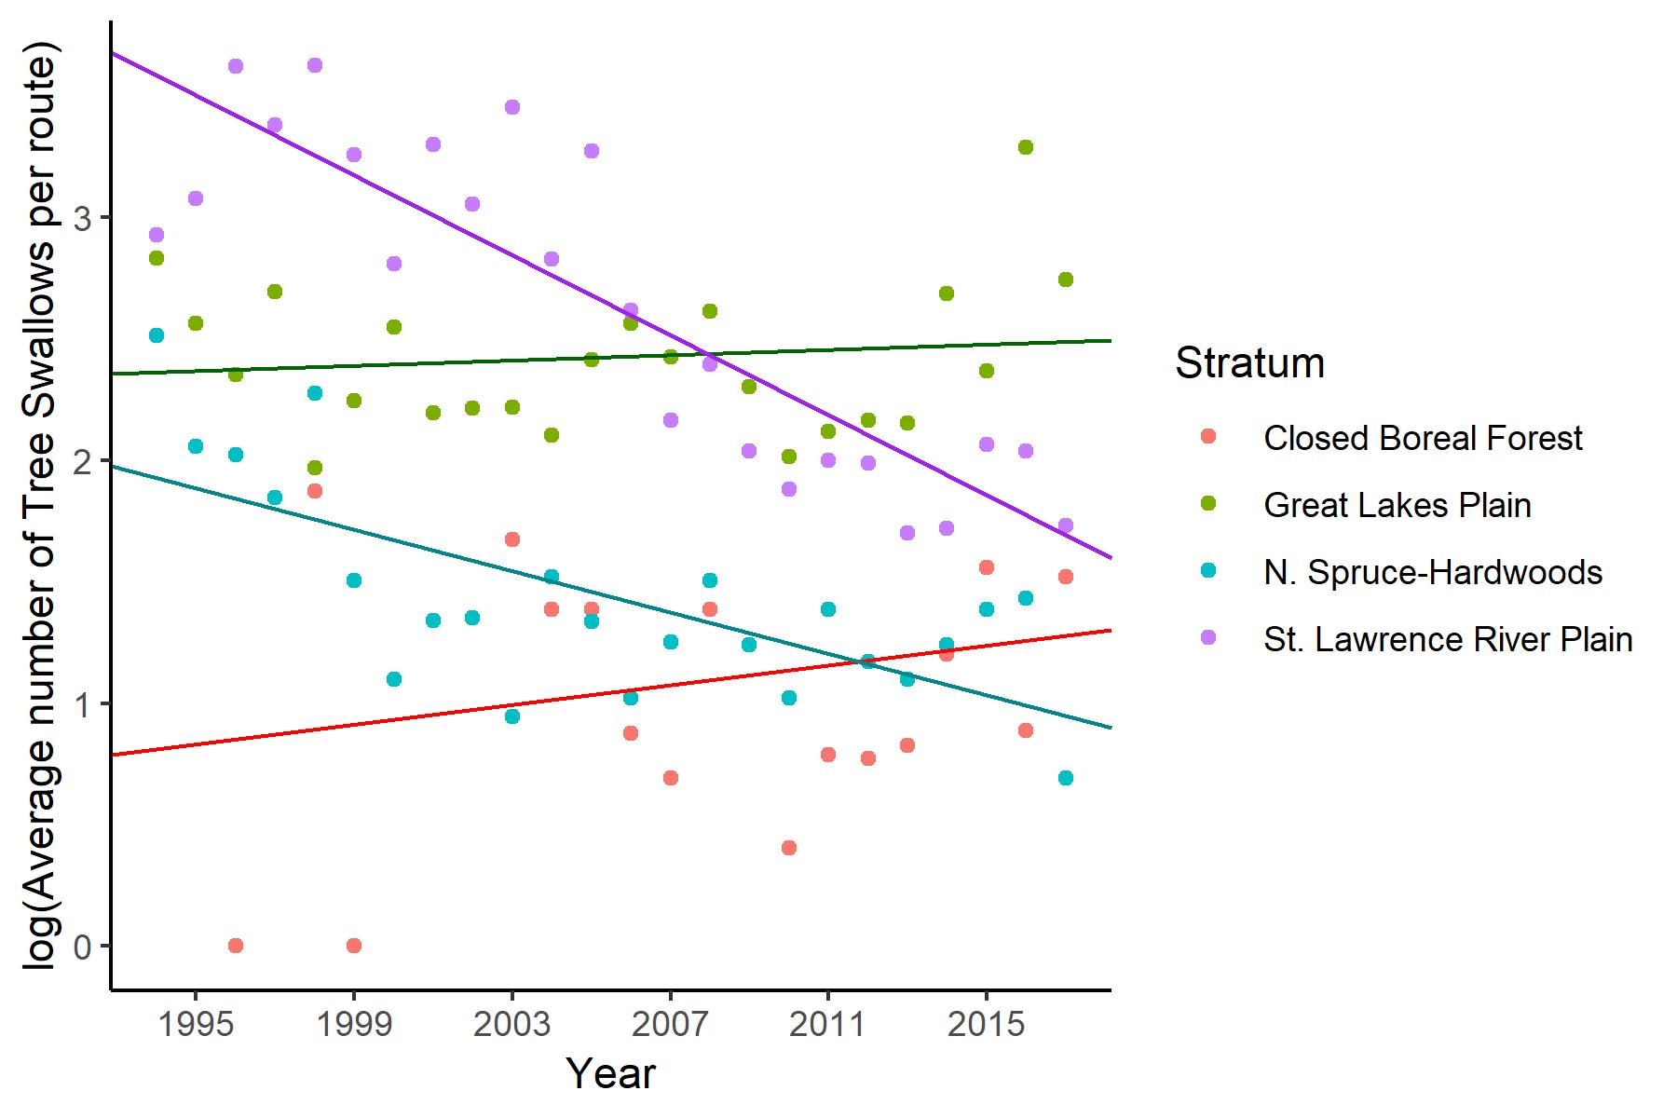

Figure 8B. Average number of Tree Swallows per route by stratum from 1994 to 2017.

Stratum, as well as the interaction between stratum and year, were significant predictors of average Tree Swallow abundance (P < 0.001, R-squared = 0.7808, n = 90). The interaction was significant for the St. Lawrence River Plain (P < 0.001) and the N. Spruce Hardwoods (P < 0.01).

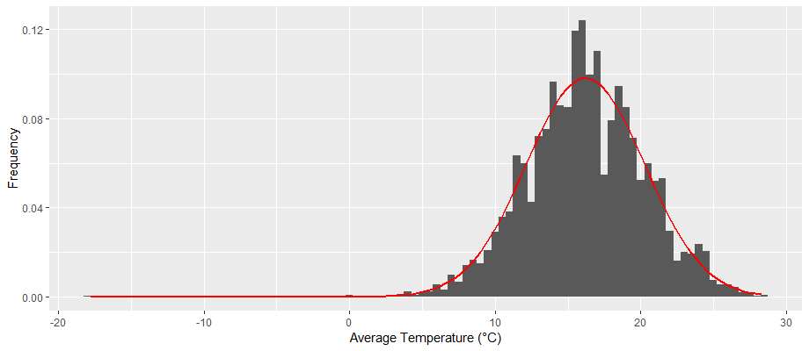

Figure 9. Normal distribution of swallows versus average temperature.

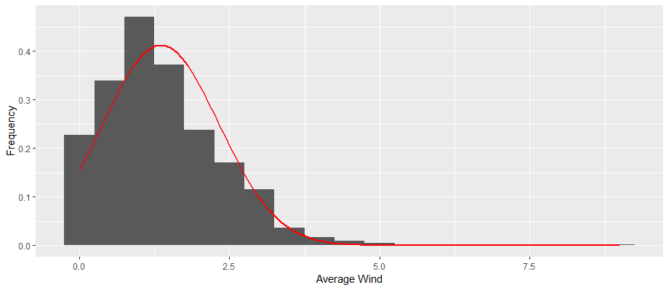

Figure 10. Normal distribution of swallows versus average wind.

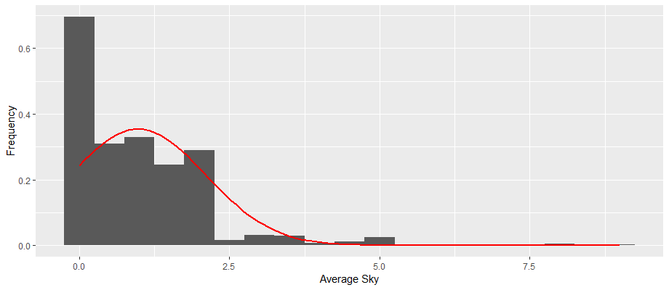

Figure 11. Normal distribution of swallows versus average sky.

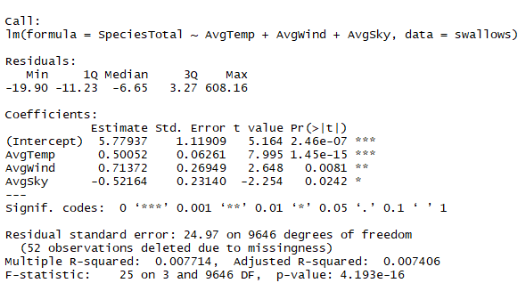

Figure 12. Summary of the linear model of swallow abundance versus temperature, wind, and sky.

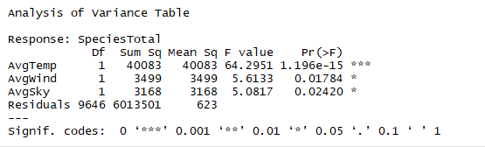

Figure 13. ANOVA of the linear model of swallow abundance versus temperature, wind, and sky.

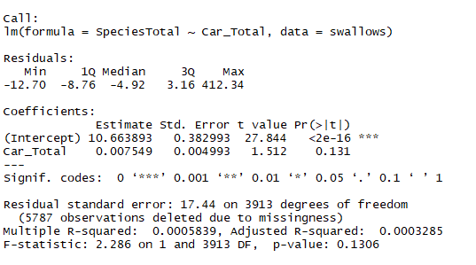

Figure 14. Summary of the linear model of swallow abundance versus the number of cars recorded.

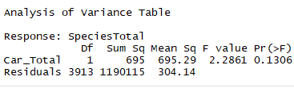

Figure 15. ANOVA of the linear model of swallow abundance versus the number of cars recorded.

**Discussion**

Most swallows appear to have experienced downwards trajectories (Figure 7). Bank Swallows and Purple Martins have decreased at a fast rate relative to other swallows, while Northern Rough-winged Swallows have maintained fairly stable numbers (Figure 7). As well, the population trends of Barn Swallows and Tree Swallows differed by stratum; both species were declining in the St. Lawrence River Plain, and Tree Swallows were also declining in the N. Spruce-Hardwoods (Figure 8A). The literature suggests that swallows, like many aerial insectivores, are experiencing widespread declines (Cox et al. 2018); our findings suggest that these widespread patterns may actually be driven by local declines. As well, this result suggests that perhaps a potential cause of swallow declines is linked, either directly or indirectly, to increased human activities in these regions of southwestern Ontario.

The significance of all three weather conditions recorded - average temperature, wind, sky - make sense in influencing numbers of swallows. Multiple studies show that local weather conditions are very important to swallow species survival (Weegman et al. 2017; Sockman et al. 2018). Swallows are insectivores that often forage over fields and wetlands; since their food supply is sensitive to weather, it is unsurprising that they too are sensitive to weather. As well, inclement weather can pose risks for a small bird (Imlay et al. 2018; Irons et al. 2017). It is possible that less swallows are simply seen when weather is unfavourable, but this doesn’t explain the overall decline in swallows over the years as we have seen in Figure 7.

Limitations of Our Study

There are some limitations associated with using BBS data. First, not every route is surveyed every year. If swallows were not recorded in a particular year, it is impossible to differentiate whether they were not present or if the route was not surveyed that year. Second, the capabilities of birders vary; it is possible that some birders made misidentifications or failed to record swallows even if they were present. Third, inclement weather conditions could decrease visibility and bird activity, this resulting in underestimated swallow counts. Fourth, BBS only provides a limited number of abiotic factors associated with the routes, which fails to provide a good explanation behind the swallow decline in our data. Due to the limitations of the dataset, we could not find many potential causes for the decline of swallow populations.

There are also some inherent limitations to studying swallows. Swallows are long-distance migrants; they encounter a variety of habitats, insect prey, and local weather conditions on their breeding grounds, wintering grounds, and migratory stops. Many factors influence the abundance of swallow population, including food availability, habitat condition and various abiotic factors, and it is difficult to pinpoint which factors are most important to the decline.

Future directions

Possible topics for future research include:

* What exact factors affect breeding success in swallows? Do reductions in preferred insect prey or anthropogenic activity play a role?
* Does habitat quality on wintering grounds or on migration affect survival rates of swallows?
* Where do most swallows winter and what are their migration routes? The exact wintering distributions and migration routes for many swallows are still unknown; knowing which areas they depend on during their full life cycle would be crucial for guiding habitat protection efforts. New radio telemetry technologies are offering many new opportunities to track birds and answer this question.
* It would be interesting to expand our analysis beyond Ontario to answer questions about swallow population trends on a continental scale. Are swallows declining in some regions faster than others?

**Conclusion**

The decline in swallow abundance over the past few decades in Ontario, especially in the St. Lawrence River Plain where there is heavy human development, is alarming. It is important to collect more data and discover the reasons behind this decline in swallows and other birds, so that we can take measures to conserve the local birds before it is too late.

Literature Cited

Bellavance V, Bélisle M, Savage J, Pelletier F, Garanta D. 2018. Influence of agricultural

intensification on prey availability and nestling diet in Tree Swallows (*Tachycineta*

*bicolor*). Can J Zool. 96(9): 1053-1065.

Cox AR, Robertson RJ, Fedy BC, Rendell WB, Bonier F. 2018. Demographic drivers of local

population decline in Tree Swallows (*Tachycineta bicolor*) in Ontario, Canada. Condor.

120(4): 842-851.

Imlay TL, Flemming JM, Saldanha S, Wheelwright NT, Leonard ML. 2018. Breeding phenology

and performance for four swallows over 57 years: relationships with temperature and

precipitation. Ecosphere. 9(4).

Irons RD, Scurr AH, Rose AP, Hagelin JC, Blake T, Doak DF. 2017. Wind and rain are the

primary climate factors driving changing phenology of an aerial insectivore. P Roy Soc

B-Biol Sci. 284(1853): 20170412.

McArthur SL, McKellar AE, Flood NJ, Reudink MW. Local weather and regional climate

influence breeding dynamics of Mountain Bluebirds (*Sialia currucoides*) and Tree

Swallows (*Tachycineta bicolor*): a 35-year study. Can J Zool. 95(4): 271-277.

Michel NL, Smith AC, Clark RG, Morrissey CA, Hobson KA. 2016. Differences in spatial

synchrony and interspecific concordance inform guild-level population trends for aerial insectivorous birds. Ecography.39(8): 774-786.

Paquette SR, Pelletier F, Garant D, Belisle M. 2014. Severe recent decrease of adult body mass

in a declining insectivorous bird population. P Roy Soc B-Biol Sci. 281(1786).

Saino N, Romano M, Caprioli M, Ambrosini R, Rubolini D, Scandolara C, Romano A. 2012. A

ptilochronological study of carry‐over effects of conditions during wintering on breeding

performance in the barn swallow *Hirundo rustica*. J Avian Biol. 43(6): 513-524.

Sicurella B, Musitelli F, Rubolini D, Saino N, Ambrosini R. 2016. Environmental conditions at

arrival to the wintering grounds and during spring migration affect population dynamics

of barn swallows *Hirundo rustica* breeding in Northern Italy. Pop Ecol. 58(1): 135-145.

Smith AC, Hudson MAR, Downes CM, Francis CM. 2015. Change points in the population

trends of aerial-insectivorous birds in North America: synchronized in time across

species and regions. PLoS One. 10(7): e0130768 .

Sockman J, Courter J. 2018. The impacts of temperature, precipitation, and growing degree-days

on first egg dates of Eastern Bluebird (*Sialia sialis*) and Tree Swallow (*Tachycineta*

*bicolor*) in Ohio. Am Midl Nat. 180(2): 207.

Leonard ML, Horn AG, Oswald KN, McIntyre E. 2015. Effect of ambient noise on

parent–offspring interactions in tree swallows*.* Anim Behav. 109(1): 1-7.

Stanton RL, Morrissey CA, Clark RG. 2016. Tree Swallow (*Tachycineta bicolor*) foraging

responses to agricultural land use and abundance of insect prey. Can J Zool. 94(9):

637-642.

Turcotte A, Belisle M, Pelletier F, Garant D. 2018. Environmental determinants of

haemosporidian parasite prevalence in a declining population of Tree swallows.

Parasitology. 145(7): 961-970.

Weegman MD, Arnold TW, Dawson RD, Winkler DW, Clark RG. 2016. Integrated population

models reveal local weather conditions are the key drivers of population dynamics in an

aerial insectivore. Oecologia. 185:119–130.